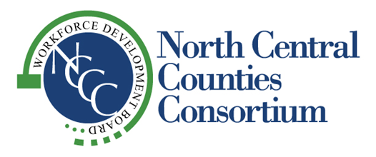
“Supporting Economic Vitality in the Counties of Colusa, Glenn, Sutter and Yuba”

NCCC GOVERNING BOARD
SPECIAL MEETING
AGENDA
THURSDAY, FEBRUARY 15, 2024
1:00 pm

Location:
Colusa Industrial Properties
100 Sunrise Boulevard
Colusa, CA

- Call to Order

- Roll

- Public Comment

- Approval of Minutes – November 27, 2024 Board Meeting (Attachment A)

- Workforce Development Board Appointments (Attachment B)
- Amy Schmidt, President, A.B.S. Builders Inc
- Cari Berlin, Owner, The Vintage Nest
- Rainey Kalfsbeek, CFO, Colusa Industrial Properties Inc.

- Closed Session: Public Employee Health Benefits (Gov. Code § 54957.6)

- Report Out in Open Session

- Other Business

- Adjournment

