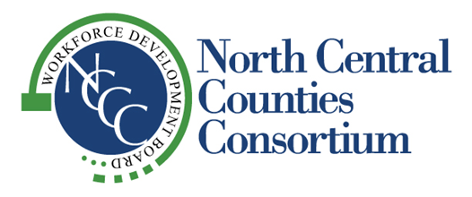
“Supporting Economic Vitality in the Counties of Colusa, Glenn, Sutter and Yuba”

NCCC
WORKFORCE DEVELOPMENT BOARD
Thursday, February 20, 2025
2:00 pm

Sutter County Superintendent of Schools – Board Room
970 Klamath Lane
Yuba City, CA

A G E N D A

1. 2:00 Call to Order John Fleming

2. Pledge of Allegiance John Fleming

3. Roll Call Tisha Smith

4. 2:05 Welcome John Fleming

5. 2:05 Public Comment

6. 2:10 Election of WDB Officers – John Fleming Action
- Nominations for Chair and Vice Chair may be taken from the Floor

7. 2:15 Approval of Minutes – John Fleming Action
- November 7, 2024 Board Meeting (Attachment A)

8. 2:20 Approval of New Grant Applications – Cindy Newton Action
- Disability Access Equity and Inclusion (Attachment B)

9. 2:25 Approval of Strategic Workforce Development Plans – Liz Barber Action
- NCCC’s Local Plan PY’s 2025-2028 (Attachment C)
- Capital Area Regional Plan PY’s 2025-2028 (Attachment D)

10. 2:35 Director’s Report – Cindy Newton Information

11. 2:40 Fiscal Committee Report (Attachment E) – Glenn Denno/Cheryl Baxter Information

12. 2:45 Sunsweet Growers Inc. – Jamie Dickerson, NCCC Board Member Presentation
and Sunsweet Vice President of Human Resources

13. 3:00 Program Performance Report – Cindy Newton Presentation
- Federal Annual Performance (Attachment F)
- Planned Vs Actual Performance (Attachment G)
14. 3:05 Service Provider Updates Information
- Colusa
- Glenn
- Sutter
- Yuba
- Upward Bound

16. 3:25 Other Business Information
- Next Board Meeting – Thursday, May 15, 2025
Location: To Be Determined

17. 3:30 Adjournment

Please note the listed times for agenda items are approximate and may change during the course of the meeting.
Agenda materials are provided to Board Members and One Stop Directors. Meeting agendas and minutes can be viewed on NCCC’s website at: http://www.northcentralcounties.com/wib.html. Other documents are available to the public upon request. NCCC is an equal opportunity employer/program. Auxiliary aids and services are available upon request to individuals with disabilities.

