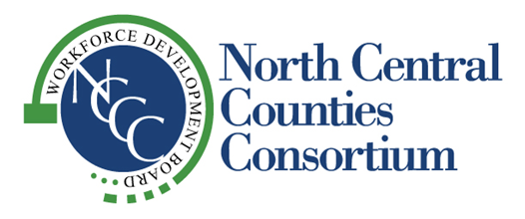
“Supporting Economic Vitality in the Counties of Colusa, Glenn, Sutter and Yuba”

NCCC
GOVERNING BOARD AND
WORKFORCE DEVELOPMENT BOARD
AGENDA
Thursday, February 15, 2024
2:00 pm

Location:
Colusa Industrial Properties
100 Sunrise Boulevard
Colusa CA

1. 2:00 Call to Order Nick Micheli

2. Pledge of Allegiance Nick Micheli

3. Roll Call Tisha Smith

4. 2:05 Welcome Nick Micheli

5. 2:10 Public Comment

6. 2:15 Governing Board Passes Meeting Over to WDB Chair

7. 2:15 Approval of Minutes (Attachment A) – John Fleming Action
- November 16, 2023 WDB

8. 2:20 Director’s Report – Cindy Newton Information

9. 2:30 Fiscal Committee Report (Attachment B) – TBD/Cheryl Baxter Information

10. 2:35 Approval of New Grant Applications (Attachment C) – Liz Barber Action
- Opportunity Young Adult Career Pathway
- Breaking Barriers 2.0/Empowerment: Focusing on Abilities, not Disabilities

11. 2:40 Freedom Home Health & Hospice Presentation
- Gurprit Bains, Owner

12. 2:50 Essential Skills (Soft Skills) Workgroup Report (Attachment D) Information
- Cindy Newton/Lorilee Niesen, Assistant Superintendent of Career
& Adult Education at Sutter County Superintendent of Schools

13. 3:00 Program Performance Report (Attachment E) – Cindy Newton Information

14. 3:05 Service Provider Program Updates Information
- Upward Bound
- Colusa
- Glenn
- Sutter
- Yuba

15. 3:25 Other Business Information
- Next Board Meeting is Thursday, May 16, 2024
Location: TBD

16. 3:25 Adjournment

Please note the listed times for agenda items are approximate and may change during the course of the meeting.
Agenda materials are provided to Board Members and One Stop Directors. Meeting agendas and minutes can be viewed on NCCC’s website at: http://www.northcentralcounties.com/wib.html. Other documents are available to the public upon request. NCCC is an equal opportunity employer/program. Auxiliary aids and services are available upon request to individuals with disabilities.

